What is Artificial Intelligence (AI)?
Artificial Intelligence is the ability of machines to seemingly think for themselves. AI is demonstrated when a task, formerly performed by a human and thought of as requiring the ability to learn, reason and solve problems, can now be done by a machine. A prime example is an autonomous vehicle. The vehicle is able to perceive its surroundings and make decisions in order to safely reach its destination with no human intervention. Converging technologies along with Big Data and the Internet of Things (IoT) are driving the growth of AI. Machines communicate with one another and are now capable of advanced perception, capturing millions of data points in seconds, processing the information and making decisions, all in a matter of seconds. As AI evolves, machines will have more capability to physically act based on their intelligence, eventually leading to machines that can build better versions of themselves.

What does Artificial Neural Network (ANN) mean?
An artificial neuron network (ANN) is a computational model based on the structure and functions of biological neural networks. Information that flows through the network affects the structure of the ANN because a neural network changes - or learns, in a sense - based on that input and output.
ANNs are considered nonlinear statistical data modeling tools where the complex relationships between inputs and outputs are modeled or patterns are found.
ANN is also known as a neural network.

What is multilayer perceptron?
Perceptron
The fundamental building block of Deep Learning is the Perceptron which is a single neuron in a Neural Network. An artificial neuron is inspired by biological neurons known as Perceptron.

Single-layer Perceptron
Perceptron has just two layers of input layers and output layers. Often called a single-layer network on
account of having 1 layer of links, between input and output. Input nodes are connected fully to a node or multiple nodes in the next layer. A node in the next layer takes a weighted sum of all its inputs.

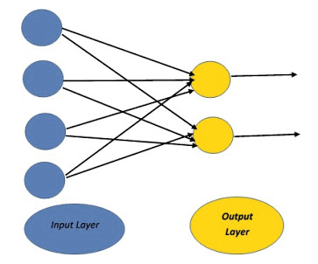

Multi-Layer Perceptron (MLP)
A multilayer perceptron (MLP) is a feed-forward artificial neural network that generates a set of outputs from a set of inputs. An MLP is a neural network connecting multiple layers in a directed graph, which means that the signal path through the nodes only goes one way. The MLP network consists of input, output, and hidden layers. Each hidden layer consists of numerous perceptron's which are called hidden layers or hidden unit.

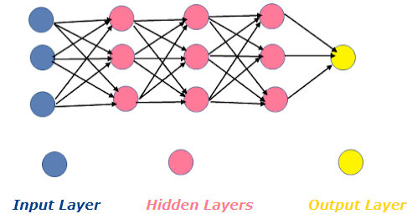

Input Layer: - The Input Layers provide information from the outside world (environment) to the network.
Hidden Layers: - Hidden Layers perform computations and transfer information from the input layer to the output layers. Hidden layers have no direct connection with the outside world.
Output Nodes: – The Output Layer are responsible for computations and transferring information from the network to the outside function (Environment).

Salient features and application of MLP are:-
- This type of network is trained with the back propagation learning algorithm.
- Multi-Layer Perceptron (MLP) can solve problems which are not linearly separable.
- Multi-layer perceptron is often applied to supervised learning problems.
- Multi-Layer Perceptron (MLP) are widely used for pattern recognition, classification, prediction, and approximation.

How does Artificial Neural Network Operate?
Basic operation of a neuron is represented diagrammatically as below:
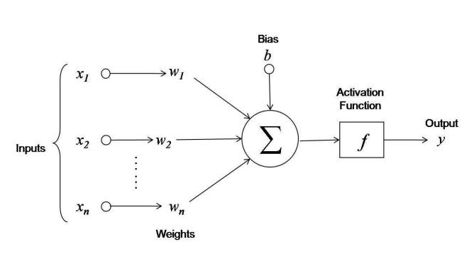
Model representation mathematically:-
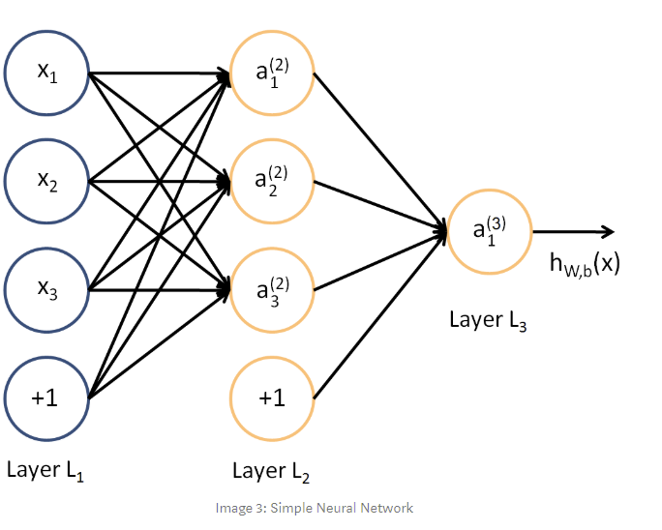
We are going to mark the “bias” nodes as x₀ and a₀ respectively. So, the input nodes can be placed in one vector X and the nodes from the hidden layer in vector A.
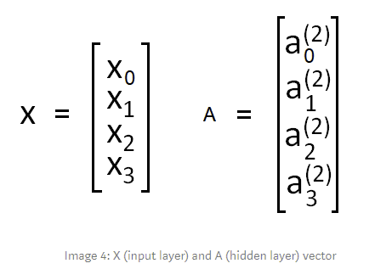
The weights (arrows) are usually noted as θ or W. In this case I will note them as θ. The weights between the input and hidden layer will represent 3x4 matrix. And the weights between the hidden layer and the output layer will represent 1x4 matrix.
If network has a units in layer j and b​ units in layer j+1, then θⱼ will be of dimension b​×(a+1).
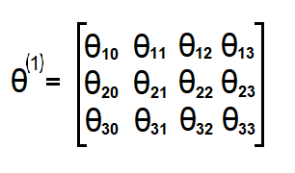
Next, what we want is to compute the “activation” nodes for the hidden layer. In order to do that we need to multiply the input vector X and weights matrix θ¹ for the first layer (X*θ¹)and then apply the activation function g. What we get is :

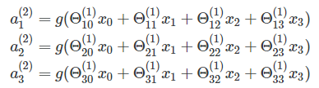
And by multiplying hidden layer vector with weights matrix θ for the second layer(A*θ) we get output for the hypothesis function:

This example is with only one hidden layer and 4 nodes there. If we try to generalize for Neural Network with multiple hidden layers and multiple nodes in each of the layers we would get next formula.

Where we have L layers with n nodes and L-1 layer with m nodes.

Activation Functions
In Neural Network the activation function defines if given node should be “activated” or not based on the weighted sum. Let’s define this weighted sum value as z.
In this case we will use “Sigmoid Function” one of the most popular activation functions. [List of activation functions to be provided during lab session]
Sigmoid Function equation is given with the formula below.
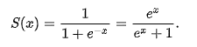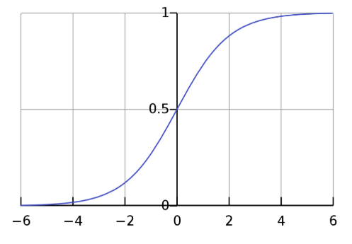
Properties:-
- It’s non-linear function
- Range values are between (0,1)
- Between (-2,2) on x-axis the function is very steep, that cause function to tend to classify values ether 1 or 0
- Because of this properties it allows the nodes to take any values between 0 and 1. In the end, in case of multiple output classes, this would result with different probabilities of “activation” for each output class. And we will choose the one with the highest “activation”(probability) value.

Using “bias” node is usually critical for creating successful learning model. In short, a bias value allows to shift the activation function to the left or right and it helps getting better fit for the data (better prediction function as output).
Below are 3 sigmoid functions , you can see how we can add/subtract/multiply the variable x and influence the function.
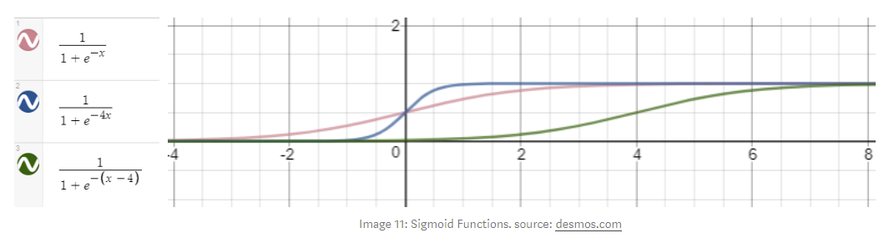

Cost Function
This function represent the sum of the error, difference between the predicted value and the real (labeled) value.
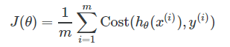
Since this is type of a classification problem y can only take discrete values {0,1}. It can only be in one type of class. For example if we classify images of dogs (class 1), cats (class 2) and birds (class 3). If the input image is dog. The output classes will be value 1 for dog class and value 0 for the other classes.
This means that we want our hypothesis to satisfy

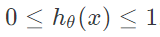
So that’s why we will define our hypothesis as
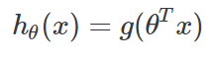
Where g in this case will be Sigmoid function, since this function has range values between (0,1).
Our goal is to optimize the cost function so we need to find min J(θ). But Sigmoid function is a “non-convex” function (“Image below”) which means that there are multiple local minimums. So it’s not guaranteed to converge (find) to the global minimum. What we need is “convex” function in order gradient descent algorithm to be able to find the global minimum (minimize J(θ)). In order to do that we use log function.

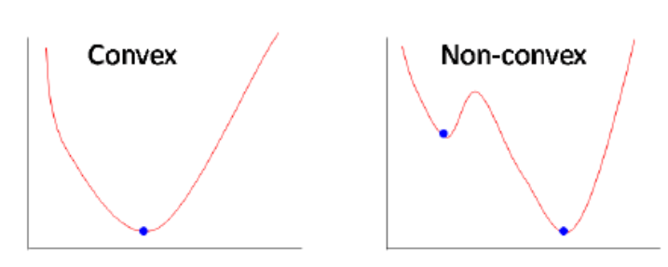
So that’s why we use following cost function for neural networks

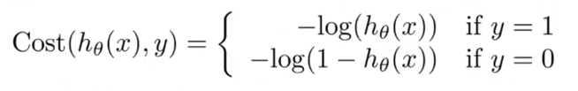
In case where labeled value y is equal to 1 the hypothesis is -log(h(x)) or -log(1-h(x)) otherwise.
The intuition is pretty simple if we look at the function graphs. Let first look at the case where y=1. Then -log(h(x)) would look like the graph below. And we are only interested in the (0,1) x-axis interval since hypothesis can only take values in that range (“Hypothesis range”)

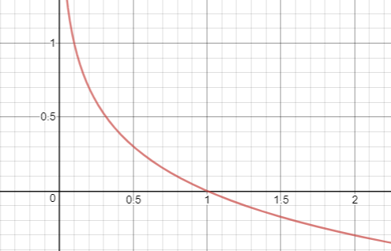
What we can see from the graph is that if y=1 and h(x) approaches value of 1 (x-axis) the cost approaches the value 0 (h(x)-y would be 0) since it’s the right prediction. Otherwise if h(x) approaches 0 the cost function goes to infinity (very large cost).
In the other case where y=0, the cost function is -log(1-h(x))

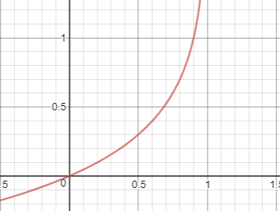
From the graph here we can see that if h(x) approaches value of 0 the cost would approach 0 since it’s also the right prediction in this case.
Since y (labeled value) is always equal to 0 or 1 we can write cost function in one equation.
If we fully write our cost function with the summation we would get:

And this is for the case where there is only one node in the output layer of Neural Network. If we generalize this for multiple output nodes (multiclass classification) what we get is:

The right parts of the equations represent cost function “regularization”. This regularization prevent the data from “overfitting”, by reducing the magnitude/values of θ.

Forward propogation?
This process of Forward propagation is actually getting the Neural Network output value based on a given input. This algorithm is used to calculate the cost value. What it does is the same mathematical process as the one described in section “Model Representation Mathematically”. Where in the end we get our hypothesis value

After we got the h(x) value (hypothesis) we use the Cost function equation to calculate the cost for the given set of inputs.

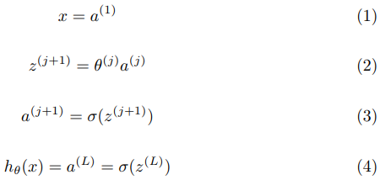

Back propogation?
What we want to do is minimize the cost function J(θ) using the optimal set of values for θ (weights). Backpropagation is a method we use in order to compute the partial derivative of J(θ).
This partial derivative value is then used in Gradient descent algorithm(given below) for calculating the θ values for the Neural Network that minimize the cost function J(θ).

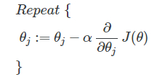
Backpropagation algorithm has 5 steps:
- Set a(1) = X; for the training examples
- Perform forward propagation and compute a(l) for the other layers (l = 2…L)
- Use y and compute the delta value for the last layer δ(L) = h(x) — y
- Compute the δ(l) values backwards for each layer (described in “Math behind Backpropagation” section)
- Calculate derivative values Δ(l) = (a(l))^T ∘ δ(l+1) for each layer, which represent the derivative of cost J(θ) with respect to θ(l) for layer l

What it does is propagating the “error” backwards in the neural network. On the way back it is finding how much each weight is contributing in the overall “error”. The weights that contribute more to the overall “error” will have larger derivation values, which means that they will change more (when computing Gradient descent).

Maths behind Backpropogation
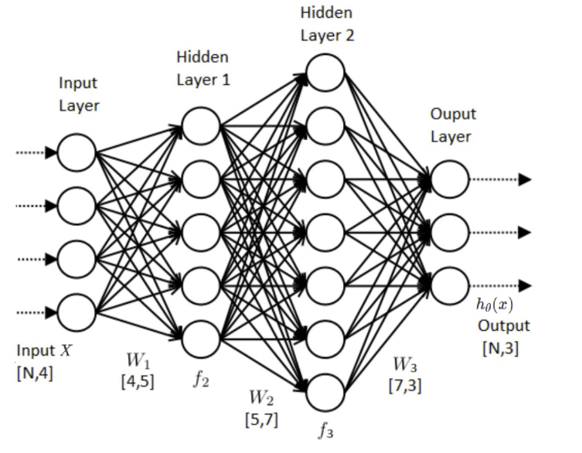
In this model we got 3 output nodes (K) and 2 hidden layers. As previously defined, the cost function for the neural network is:
Image 27: Generalized Cost function.

What we need is to compute the partial derivative of J(θ) with respect to each θ parameters. We are going to leave out the summarization since we are using vectorized implementation (matrix multiplication). Also we can leave out the regularization (right part of the equation above) and we will compute it separately at the end. Since it is addition the derivative can be computed independently.

NOTE: Vectorized implementation will be used so we calculate for all training examples at once.We start with defining the derivative rules that we will use.

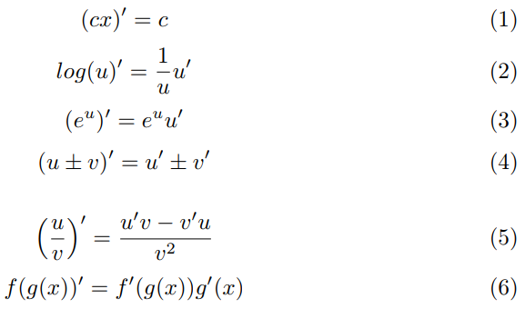
Image 28: Derivative Rules
Now we define the basic equation for our neural network model where l is layer notation and L is for the last layer.

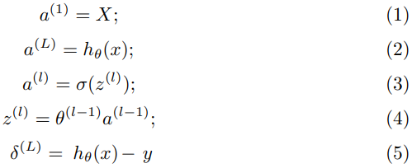
Image 29: Initial Neural Network model equations

In our case L has value 4, since we got 4 layers in our model. So let’s start by computing the partial derivative with respect to weights between 3rd and 4th layer.

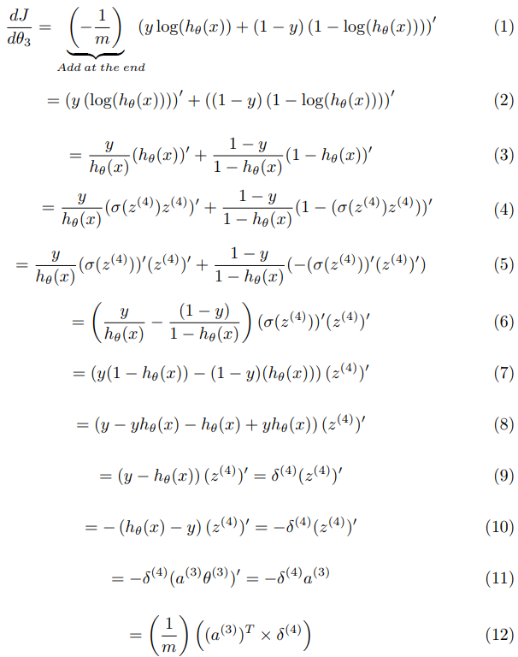
Image 30: Derivative of θ parameters between 3rd and 4th layer
Step (6) — Sigmoid derivative
To explain the step (6) we need to calculate the partial derivative of sigmoid function.

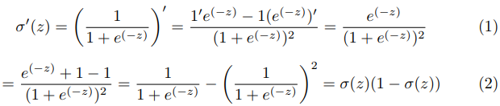
Image 31: Derivative of Sigmoid function
In case of the last layer L we got,

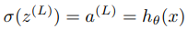
Image 32: Output layer equation
so,

Image 33: Output layer equation
Step (11) — Get rid of the summarization (Σ)
Also in the last step (11) it’s important to note that we need to multiply δ by a transpose in order to get rid of the summarization (1…m for training examples).
δ — matrix with dimensions
[number_of_training_examples, output_layer_size] so this also means that we will get rid from the second summarization (1…K for number of output nodes).
a — matrix with dimensions
[hidden_layer_size, number_of_training_examples]
Now we continue with the next derivative for the θ parameters between 2nd and 3rd layer. For this derivation we can start from step (9) (“Image 30”). Since θ(2) is inside a(3) function we need to apply the “Chain Rule” when calculating the derivative (step(6) from derivative rules on “Image 28”).

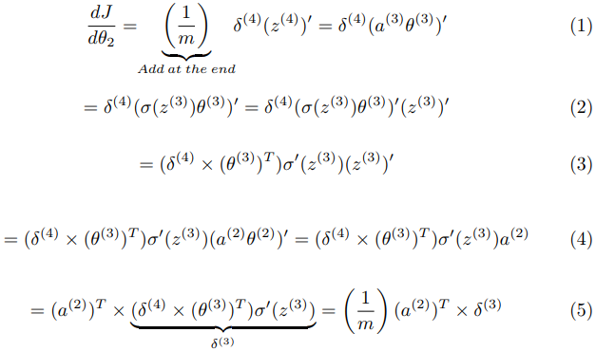
Image 34: Derivative of θ parameters between 2nd and 3rd layer
Now we got the derivative for θ parameter between 2nd and 3rd layer. What we left to do is compute the derivative for θ parameter between input layer and 2nd layer. By doing this we will see that the same process (equations) will be repeated so we can derive general δ and derivative equations. Again we continue from step (3) (“Image 34”).

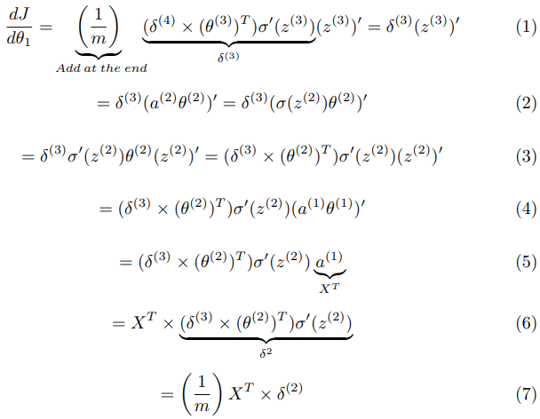
Image 35: Derivative of θ parameters between input and 2nd layer
From the equation above we can derive equations for δ parameter and derivative with respect to θ parameter.

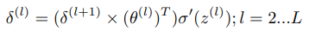
Image 36: Recursive δ equation

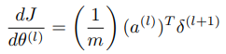
Image 37: Derivative of J (cost) with respect to θ in layer l equation
At the end we get is three matrices (same as θ weight matrices) with same dimensions as the θ weight matrices and calculated derivatives for each θ parameter.
Add the regularization
As already mentioned regularization is needed for preventing the model from overfitting the data. We have already defined regularization for our cost function which is the right part of the equation defined on “Image 21“.

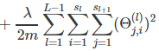
Image 38: Regularization equation for Cost function
In order to add the regularization for the gradient (partial derivative) we need to compute the partial derivative for the regularization above.

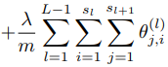
Image 39: Regularization equation for gradient (partial derivative)
Which means just adding the sum of all theta values from each layer to the partial derivatives with respect to θ.

Self Organizing maps:-
- A self-organizing map (SOM) is a type of artificial neural network (ANN) that is trained using unsupervised learning & provides a data visualization technique which helps to understand high dimensional data by reducing the dimensions of data to a map. SOM also represents clustering concept by grouping similar data together. Therefore it can be said that SOM reduces data dimensions and displays similarities among data...
- Self-organizing maps differ from other artificial neural networks as they apply competitive learning as opposed to error-correction learning (such as backpropagation with gradient descent), and in the sense that they use a neighborhood function to preserve the topological properties of the input space.

SOM was introduced by Finnish professor Teuvo Kohonen in the 1980s is sometimes called a Kohonen map.
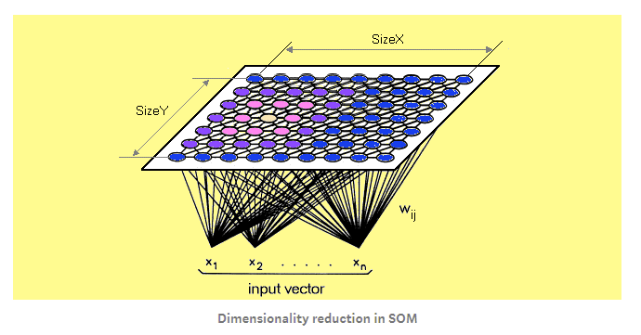
Working in SOM:
- Each data point in the data set recognizes themselves by competing for representation.
- SOM mapping steps starts from initializing the weight vectors.
- From there a sample vector is selected randomly and the map of weight vectors is searched to find which weight best represents that sample.
- Each weight vector has neighboring weights that are close to it. The weight that is chosen is rewarded by being able to become more like that randomly selected sample vector.
- The neighbors of that weight are also rewarded by being able to become more like the chosen sample vector. This allows the map to grow and form different shapes.
- Most generally, they form square/rectangular/hexagonal/L shapes in 2D feature space.
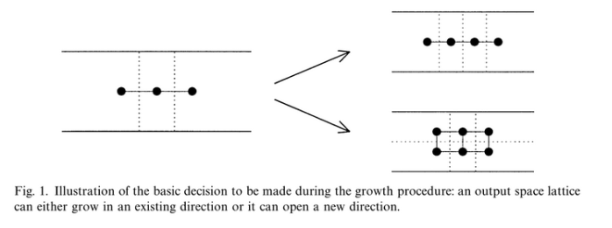The Algorithm:
- Each node’s weights are initialized.
- A vector is chosen at random from the set of training data.
- Every node is examined to calculate which one’s weights are most like the input vector. The winning node is commonly known as the Best Matching Unit (BMU).
- Then the neighborhood of the BMU is calculated. The amount of neighbors decreases over time.
- The winning weight is rewarded with becoming more like the sample vector. The neighbors also become more like the sample vector. The closer a node is to the BMU, the more its weights get altered and the farther away the neighbor is from the BMU, the less it learns.
- Repeat step 2 for N iterations.
http://blog.yhat.com/posts/self-organizing-maps-2.html
Best Matching Unit is a technique which calculates the distance from each weight to the sample vector, by running through all weight vectors. The weight with the shortest distance is the winner. There are numerous ways to determine the distance, however, the most commonly used method is the Euclidean Distance, and that’s what is used in the following implementation.

